Candy Crush Style Map

Allows user to access options/quit/save options

Background: designed like a university room/hall?

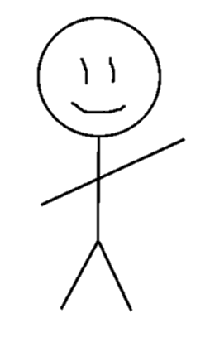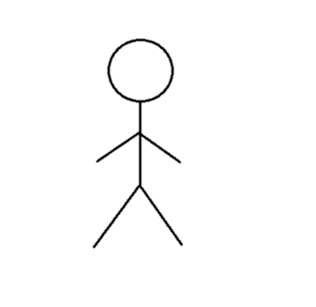

Clicking on levels gives brief information on opponent

Lecturers along the way to give advice/tell a story?

Opponents also stand at levels?

Character moves from level to level, progressing to the next battle

Button to view cards/stats

Menu

Tile Based Map

Background: designed like a university classroom/hall

User can encounter lecturers that give them tips

When entering a new area different things generate each time e.g. new opponents/items

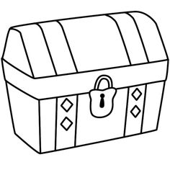

Can click on character to bring up cards/stats?

Can look in chests/other items to find cards

Character moves through the room – tap and hold in a direction to move?

Can encounter opponents to battle – talks to user to start a battle